POC Report — NICo Site Controller: End-to-End Bare-Metal Provisioning of HGX B300
Nov 5, 2026 · @Vinod Konisa

Executive summary
Verdict: PASS. NICo took an HGX B300 from an unknown machine to a freshly installed Ubuntu 24.04.3 host with no manual OS steps. The run ended on 5 Nov 2026 at 00:04 UTC, when an SSH login with key-only auth succeeded.
- Discovered the node through its BMC (Redfish), created machine fm100htcm1…, and took ownership of BMC and UEFI credentials.
- Configured BIOS and boot order, network-booted its inventory agent (scout), and passed machine validation. The machine reached READY.
- Installed Ubuntu 24.04.3 by UEFI HTTP boot and unattended autoinstall, about 21 minutes from allocation to SSH.
The POC ran in zero-DPU (NIC) mode on existing VLAN 30, with no new VLANs. Getting this Supermicro B300 through NICo took five fixes:
- a BMC firmware upgrade;
- NICo patches for Supermicro BIOS writes;
- a scout fix for the NVLink management NIC;
- a DNS resolver (Unbound) deployment;
- an SNMP setting workaround.
The next phase repeats the test in DPU mode, booting through the BlueField card.

Objective, scope and success criteria
The objective was to prove that the NICo site controller can drive a real HGX B300 end to end: talk to its BMC, PXE-boot it, and install a new OS image without hands on the server.
In scope: one B300 node; NICo on a 4-node Kubernetes cluster (Proxmox Ubuntu VMs); zero-DPU / NIC mode; the existing VLAN 30 network; Ubuntu 24.04.3 as the target image; wiping the node's disks (approved).
Out of scope: DPU mode and BlueField provisioning; tenant overlay networking; GPU drivers and Fabric Manager; multi-node scale; the nico-rest tenant API path.
# | Success criterion | Result | Evidence
1 | NICo discovers the node through its BMC and creates a machine record | Pass | Site Explorer created fm100htcm1d9bk… (BMC 7C:C2:55:92:68:E7)
2 | NICo configures BIOS and boot order through Redfish | Pass, with patches | SetBootOrder → CheckBootOrder → Measuring on 4 Nov 15:20–16:51Z (patched images bios-sd3)
3 | The node network-boots NICo's agent and reports its inventory | Pass, with a scout fix | Scout DISCOVERY outcome=ok, 4 Nov 22:18Z
4 | Machine validation passes and the machine reaches READY | Pass | Run ebef13fc-… Completed(Success) 22:34–22:46Z; READY
5 | NICo installs a new OS image by PXE with no manual steps | Pass | Instance 554ad82e-… allocated 23:42:55Z; autoinstall over UEFI HTTP
6 | Access to the new OS with key-only SSH | Pass | ssh digi@10.10.30.81 on 5 Nov 00:04Z; Ubuntu 24.04.3, kernel 6.8.0-147
7 | No new VLAN required | Pass | Everything ran on VLAN 30 + the existing borderleaf DHCP relay

Test environment
Two networks were used. The NICo control plane ran on 10.11.1.0/24 (Proxmox VMs); the B300, its BMC and the jump host sat on VLAN 30 (10.10.30.0/24, gateway .254). The borderleaf switches relay DHCP between them.
Component | Address | Role | Version / detail
HGX B300 (Supermicro PIO-422GS-NB3RT) | host 10.10.30.81 | Target node; PXE NIC = onboard X710 port 0, 90:5A:08:C1:92:62 | S/N S989423X6713063; Ubuntu 24.04.3 after the test
B300 BMC | 10.10.30.77 (static) | Redfish/IPMI endpoint NICo drives | FW 01.12.02.03 (upgraded from 01.07.00.02); LAN Failover, active on Shared port
digi-p2-nico-01 | 10.11.1.99 | NICo install host; OS-image web server on :8090 | /root/infra-controller, KUBECONFIG=~/.kube/tf-poc.config
digi-p2-tf1 | 10.11.1.101 | Kubernetes control plane; admin CLI workstation | nico-admin-cli v2.3.0, Vault-issued mTLS admin cert
tf2–tf4 | 10.11.1.102–.104 | Kubernetes workers running NICo pods | Kubernetes v1.30.4
NICo VIPs (MetalLB) | DHCP .105 · PXE .106 · Unbound .108 · NTP .109–.111 · API .116 · REST .120 | NICo services | Helm release nico rev 4; nico-api v2.0.0-nico-bios-sd3
digi-srvr | 10.10.30.19 | Jump host on VLAN 30; BMC tooling | ipmitool, curl/jq scripts in ~/nico-lab
borderleaf1/2 | relay .250/.251 | DHCP relay VLAN 30 → nico-dhcp | Pre-existing config
NICo site settings for the test: segment vlan30-hostinband (reserved-only DHCP, BMC .77 and host .81 reserved); dpu_policy: ignore; DPF off; tenant ncx with flat VPC bootstrap-flat-vpc.

Architecture
NICo never touches the host directly. It drives the BMC over Redfish, then serves everything the host asks for while booting: DHCP, iPXE, scout, DNS and the OS image.
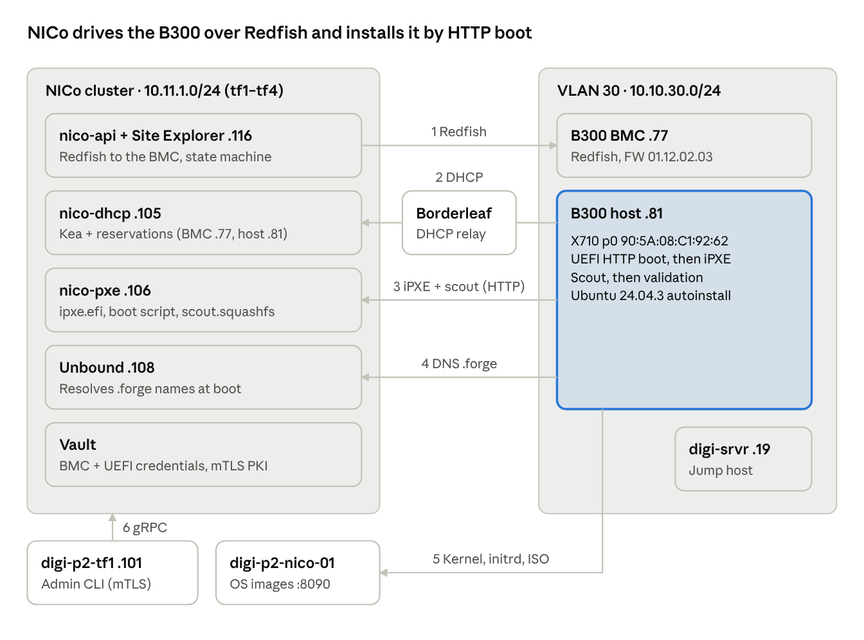
POC architecture · control plane, VLAN 30 and the six flows
The numbers follow one provisioning pass:
- Site Explorer and the state machine configure the node through the BMC.
- The host's DHCP request is relayed by the borderleaf switches to nico-dhcp.
- The host fetches iPXE and scout from nico-pxe over HTTP; later it fetches the OS boot script.
- Unbound resolves .forge names on the boot path.
- The installer pulls the kernel, initrd and ISO from nico-01.
- tf1 issues admin commands to nico-api over mTLS gRPC.
Vault holds the credentials NICo rotates.

Test procedure
The test ran in four phases over 3–5 Nov 2026. Each step had a check before moving on.
- Preparation
  - Collected B300 facts from the BMC: MAC, serial, the PXE NIC, UEFI mode. Got approval to wipe the node.
  - Checked NICo health: 4/4 nodes Ready, all pods Running, MetalLB VIPs assigned.
  - Confirmed the network design: segment vlan30-hostinband plus the borderleaf DHCP relay. No relay was needed on digi-srvr.
  - Gave tf1 admin CLI access: the binary copied from the nico-api pod, an mTLS admin certificate issued from Vault PKI, and a hosts entry for the API name.
- Registration
  - Created the expected-machine record: BMC MAC, factory credentials, chassis serial, reserved IPs, dpu_policy ignore, lockdown disabled.
  - Site Explorer found the BMC through DHCP and Redfish and created a predicted host machine.
- Host takeover
  - Fixed the BMC Redfish 500 errors with a firmware upgrade to 01.12.02.03.
  - Root-caused the BIOS setup failure: this firmware only accepts writes on /Bios/SD, and boot order only through Supermicro's FixedBootOrder. The team patched NICo (libredfish 0.47.25 + vendor patch, images bios-sd → sd3).
  - Set UEFI HTTP IPv4 on the X710 first in the boot order. NICo then passed SetBootOrder, CheckBootOrder and Measuring.
  - Deployed Unbound (Helm rev 4) so the host could resolve .forge names at boot.
  - Network-booted scout. Fixed scout failing to reset the HGX NVLink management NIC (skip-on-failure patch), and scout then completed DISCOVERY.
  - NICo set the UEFI password, ran machine validation (Success) and moved the machine to READY.
- OS install
  - Served the Ubuntu 24.04.3 kernel, initrd and ISO from nico-01 on :8090. Confirmed they are reachable from VLAN 30.
  - Created OS definition ubuntu-24.04.3-autoinstall: an iPXE script plus cloud-init autoinstall user-data (user digi, SSH key only).
  - Allocated an instance on the B300 in the flat VPC. This needed --cloud-unsafe-op, because nico-rest manages the site.
  - NICo rebooted the host into UEFI HTTP boot. iPXE pulled the installer, which ran unattended and rebooted into Ubuntu.
  - Verified with an SSH login as digi using the key.

Results and evidence
The node went from patched platform config to SSH in the new OS in about 7 hours on 4 Nov. Most of that was the scout fix; the OS install itself took about 21 minutes. Times are UTC, newest first.
Time (UTC) | Milestone | Evidence
5 Nov 00:04 | SSH into the new OS as digi with a key | Ubuntu 24.04.3 LTS, kernel 6.8.0-147-generic, hostname b300-01, / 3.44 TB, ens3923f0np0 = 10.10.30.81
4 Nov 23:42:55 | Instance allocated; NICo starts the install | Instance 554ad82e-3345-43b7-a24a-adc39ec96bd3, configs Synced, IP 10.10.30.81/24
4 Nov 23:33 | OS definition created | f6fca038-2b71-46c4-a2b4-5fab7ebf7278, OS_TYPE_IPXE, org ncx
4 Nov ~23:20 | Machine READY | State path: Discovery → UefiSetup → Lockdown → MachineValidation → BootConfiguring → Ready
4 Nov 22:34–22:46 | Machine validation Completed(Success) | Run ebef13fc-0eff-497d-8d7c-6c4189f96433
4 Nov ~22:22 | NICo set the UEFI setup password and power-cycled the host | UefiSetup state; credential stored in Vault
4 Nov 22:18 | Scout DISCOVERY outcome=ok | After the scout IB-reset fix (new scout.squashfs 22:03)
4 Nov 17:20 | Unbound DNS live at 10.11.1.108 | .forge names resolve: pxe → .106, api → .116
4 Nov 15:20–16:51 | Platform config passed: SetBootOrder → CheckBootOrder → Measuring | Patched nico-api v2.0.0-nico-bios-sd3
3 Nov | BMC firmware upgraded to 01.12.02.03; Redfish 20/20 endpoints OK | Previously HTTP 500 on several endpoints
3 Nov | Site Explorer discovered the BMC; machine created | Machine fm100htcm1d9bklehq3ranjmlr6r6pk4pn1rb5p5jck8ipg65hna7j8hhm0 (permanent ID)
The installed image matched the definition: the hostname, user, key-only SSH and direct storage layout all came from the autoinstall user-data that NICo served at ${tenant-cloudinit-url}.

Issues found and resolutions
The test hit 11 blockers or defects. Seven are resolved; four are open but did not block the test. Most come from Supermicro Redfish behaviour that NICo did not expect on this firmware.
# | Issue | Impact | Resolution | Status
1 | BMC Redfish returned HTTP 500 on several endpoints (FW 01.07.00.02) | Site Explorer could not explore the BMC | BMC firmware upgraded to 01.12.02.03 | Resolved
2 | NICo wrote BIOS settings to /Bios; this firmware only accepts /Bios/SD (405) | BIOS setup failed; NICo force-restarted the host about 10 times in 2 h | Team patch: libredfish 0.47.25 + vendor patch (image bios-sd → sd3) | Resolved (patched build)
3 | Boot.BootOrder PATCH rejected (400 PropertyUnknown) | Boot order could not be set the standard way | Supermicro OEM FixedBootOrder, X710 UEFI HTTP IPv4 first | Resolved (workaround)
4 | BIOS value names and spellings differ from NICo's expectations (e.g. Enable vs Enabled) | CheckBootOrder / platform config mismatch | Part of the team patch + manual BIOS staging | Resolved (patched build)
5 | NetworkProtocol SNMP fields null; NICo failed to parse | Exploration error | Set CommunityAccessMode=Limited, HideCommunityStrings=true (SNMP stays off) | Worked around; NICo should accept nulls
6 | No resolver for .forge names on the boot path | iPXE/scout could not reach PXE and API by name | Unbound deployed (Helm rev 4, 10.11.1.108) | Resolved
7 | Scout IB reset failed on the HGX NVLink management NIC (a8:00.x) | DISCOVERY aborted | Scout patch: skip the device on failure, with a WARN | Resolved (patched build)
8 | Lockdown PATCH Managers/1/HostInterfaces/1 returns 400 (×12) | Host interface lockdown not applied | None yet; state machine continued | Open
9 | DMI chassis serial is the placeholder 0123456789 | May break serial/SKU matching later | Vendor to program the FRU | Open
10 | BMC shares X710 port 0 (NC-SI); dedicated port not linked | Brief Redfish timeouts during host NIC resets | Cable the dedicated BMC port | Open
11 | Admin-CLI allocation is blocked on a nico-rest-managed site | Needed --cloud-unsafe-op; nico-rest does not own the instance | Use the REST API for production allocations | Open (by design)

Findings, limitations and risks
The provisioning flow works on the B300, but only with patched NICo images that are not yet tracked in Helm. That is the biggest risk before anyone scales this.
Findings
- Supermicro B300 firmware needs vendor-specific handling: BIOS writes to /Bios/SD, boot order through FixedBootOrder, null SNMP fields. Upstream NICo does not support this yet.
- NICo's lifecycle state machine (discovery → validation → READY → assign → install) worked as designed once the platform calls succeeded.
- The install path is plain UEFI HTTP + iPXE + cloud-init autoinstall, so any OS with an autoinstall/kickstart flow can use the same pattern.
- NICo takes ownership of credentials: it rotates the BMC root password and sets a UEFI password, both stored in Vault. People who need BMC access afterwards must read them from Vault.
Limitations of this POC
- Zero-DPU mode only: no BlueField, no overlay or tenant isolation. The host sits directly on VLAN 30.
- Static reservations (BMC .77, host .81) rather than dynamic allocation.
- A single node. The instance was created through the admin CLI, not the nico-rest tenant API.
- The OS image is served by a transient python web server on nico-01, which is not reboot-safe.
- GPU drivers, Fabric Manager and NVLink health were not tested.
Risks
- A routine helm upgrade nico reverts nico-api and nico-pxe to unpatched images; nico-pxe still reuses the tag v2.0.0-nico. The B300 then fails BIOS setup and scout again.
- The scout fix reset functions a8:00.2/.3 of the NVLink management NIC before skipping. Production should skip the whole device.
- Lockdown is not applied (issue 8), so the host can still reach the BMC host interface.
- The admin CLI certificate expires on 3 Dec 2026. A BMC password was exposed in chat during the test and must be rotated.

Recommendations and next phase
Recommendation: accept the POC as proof of NIC-mode provisioning, lock in the fixes, then run phase 2 in DPU mode.
Before any further work
- ☐ Commit the team patches, build them under unique image tags and pin those tags in the Helm values.
- ☐ Report the Supermicro behaviours (Bios/SD, FixedBootOrder, SNMP nulls, lockdown 400) and the scout NVLink-NIC issue to NVIDIA, with the logs.
- ☐ Rotate the exposed BMC password, cable the dedicated BMC port, and ask Supermicro to program the chassis serial.
- ☐ Make the OS-image server permanent (a systemd unit or an in-cluster service) and renew the CLI certificate before 3 Dec 2026.
Phase 2 (Run 2) scope
- Dynamic IP allocation from NICo pools inside VLAN 30, with no new VLAN.
- Registration through the standard NICo flow, with the real chassis serial and the DPU serial.
- DPU mode: NICo provisions the BlueField-3 (BFB, HBN, BGP to the leaf), and the host boots through the Mellanox card.
- Tenant network config (a VPC that isn't flat, plus a VPC prefix) and SSH keys injected at boot through a tenant keyset and user-data.
- Allocation through the nico-rest API instead of the admin CLI.
Prerequisite: confirm a BlueField-3 is installed in the B300 and cabled to the leaf. The detailed plan and gate checklist are in B300 NICo — Change Checklist & Re-run Plan.

Appendix
Identifiers
Object | Value
Machine ID | fm100htcm1d9bklehq3ranjmlr6r6pk4pn1rb5p5jck8ipg65hna7j8hhm0
Validation run | ebef13fc-0eff-497d-8d7c-6c4189f96433
OS definition | f6fca038-2b71-46c4-a2b4-5fab7ebf7278 (ubuntu-24.04.3-autoinstall)
Instance | 554ad82e-3345-43b7-a24a-adc39ec96bd3 (b300-01_0)
Flat VPC | 7b357b5b-7fa4-4c55-b1bb-d852660df9c5 (bootstrap-flat-vpc, tenant ncx)
BMC MAC / PXE NIC MAC | 7C:C2:55:92:68:E7 / 90:5A:08:C1:92:62
OS image URLs | http://10.11.1.99:8090/ubuntu-24.04.3/{vmlinuz,initrd,ubuntu-24.04.3-live-server-amd64.iso}
OS definition — iPXE script
#!ipxe
kernel http://10.11.1.99:8090/ubuntu-24.04.3/vmlinuz BOOTIF=01-${netX/mac:hexhyp} ip=dhcp fb=false url=http://10.11.1.99:8090/ubuntu-24.04.3/ubuntu-24.04.3-live-server-amd64.iso autoinstall ds=nocloud-net;s=${tenant-cloudinit-url} console=tty0 console=ttyS1,115200 initrd=initrd.magic
initrd http://10.11.1.99:8090/ubuntu-24.04.3/initrd
boot
Key commands (run on tf1)
nico-admin-cli operating-system create --name ubuntu-24.04.3-autoinstall --org ncx \
--ipxe-script "$(cat ubuntu-24.04.3.ipxe)" --user-data "$(cat ubuntu-24.04.3.user-data)"
OS_JSON=$(jq -nc --arg id f6fca038-2b71-46c4-a2b4-5fab7ebf7278 --rawfile ud ubuntu-24.04.3.user-data \
'{variant:{OperatingSystemId:$id},phone_home_enabled:false,run_provisioning_instructions_on_every_boot:false,user_data:$ud}')
nico-admin-cli --cloud-unsafe-op vinod instance allocate \
--machine-id fm100htcm1d9bklehq3ranjmlr6r6pk4pn1rb5p5jck8ipg65hna7j8hhm0 \
--flat-vpc-id 7b357b5b-7fa4-4c55-b1bb-d852660df9c5 --tenant-org ncx --prefix-name b300-01 --os "$OS_JSON"
The --os JSON uses serde tagging: the variant is OperatingSystemId (PascalCase) with a plain UUID string. Other spellings are rejected, or parse with no OS.
Related documents
- B300 NICo End-to-End Validation Runbook
- B300 NICo — Change Checklist & Re-run Plan
- Live status tracker
No credentials appear in this report; BMC, UEFI and admin credentials are held in NICo's Vault.

